Research on the Application System of
Smart Campus in the Context of Smart City

Shouyan Du
Institute of Information Science and Technology
Shandong Normal University
Jinan, China
dushouyan666@126.com
Fansheng Meng
Institute of Information Science and Technology
Shandong Normal University
Jinan, China
535361162@qq.com
Baozhong Gao
Institute of Information Science and Technology
Shandong Normal University
Jinan, China
13335108130@126.com

Abstract—Based on the construction of Shandong Normal University’s smart model, this paper researches the key technologies of OAuth authentication and data analysis. Through the analysis of the design, and implementation procedure of the smart campus platform, this paper summarizes the research methods of building the smart campus application system with existing educational resources. Also, it provides a universal reference to the construction of an urban intelligence system.
Keywords-Smart Campus; Smart City; OAuth Authentication; Data Analysis; IoT

Introduction
"Smart campus" refers to integrating all kinds of application service systems, setting up a wise, intelligent teaching, learning, and living environment, which is suitable for: management, teaching, scientific research, and campus life unity, as well as based on the Internet of things ^{[1]}, forming an integrated system with cooperation and self-adjustment capability.
According to the requirements of the Ministry of Education’s "Ten year development plan of Educational Information (2011-2020)", based on strengthening the construction and application of the digital campus, making use of the advanced network and information technology to integrate resources, constructing the advanced, efficient, and practical higher education information infrastructure ^{[2]}; this paper uses the work at Shandong Normal University as an example of how the design and reality of the smart campus application system promotes the construction process of the school information, and how it significantly improves the school’s management and service capabilities.

The Overall Design of the Smart Campus

Overall Structure
Our smart campus architecture is mainly divided into four parts: the main work of the Infrastructure Layer is based on the wired campus net, through the technologies and equipment such as RFID identification, infrared detectors, video capture, and GPS to dynamic monitoring and acquisition of campus information. Timely and accurate collecting and processing all kinds of information, and transferring the information which is collected from the hardware equipment into the data layer safely; The Data Layer is responsible for classifying and conserving real-time data which manages service distribution^{[4]}; the main work of the Application Service Layer is to make full use of cloud computing and cloud storage technologies, integrate and manage all kinds of information effectively, and achieve a unified management of information; Information Provider Layer provides a specific and effective service platform for teachers and students, working as a unified portal service directly interacting with the users.

Key Technology

OAuth authentication
OAuth is an open license agreement, which provides a secure and reliable framework for third party applications to access HTTP services with certain authority and limitations ^{[5]}. Our smart campus uses the version of OAuth 1.0A and xAuth, which due to security problems, currently, only opens OAuth 1.0A interface to all teachers and students.
The license process of OAuth 1.0A interface is divided into three steps:

Unauthorized Request Token: Service users (applicants) who request unauthorized Request Token to “SMART SDNU”, regardless of whether the request is successful or not, will return to the text string with the Content Type of "text/plain ". After successfully making a request, the server will return to the aforementioned unauthorized Request Token ID and Request Token corresponded key, as well as the confirmation information of the setting Callback, and those three fields using "&" connected with each other.

User identity authorization: Service users can request the user identity authorization to “SMART SDNU”. While accessing the net, the acquired Request Token ID should be included in the OAuth_token parameter. Then our system guides the user to access the authorization page (only required the first time), then the user can log in with their account, as well as agree or refuse authorization; if the user has been authorized, it will go directly to the last set of Callback addresses, finally, the Request Token will become authorized after it is accepted by the user.

Acquire user’s information: Service users exchange the authorized Request Token for Access Token, after the third party application gains access to the Access Token, it can obtain the permission to acquire users data using the specified information interface.

Data analysis platform
The process flow of Data Layer is divided into three steps:

Data collection and processing: “SMART SDNU” through integrating its own data, capturing storage data, analyzing and grabbing storage data, collecting pushed data from other places, and real time data to consist of database access layer. This becomes a data layer after adding other Web service requests, which cannot directly access the database. Big data can be used to identify trends, and reach conclusions about the urban environment, including incidents that happen therein and ultimately allow school management to be more effective, equitable, and smart ^{[6]}.

Logical model design of data warehouse:
- To analyze the theme of the conceptual model design, select the subject area to be implemented first.
- Determine the granularity partition hierarchy of data warehouse: the rationality of the division level of granularity directly affects the amount of data in the data warehouse and the appropriate type of query.
- Partition the theme of the selected current implementation, form a number of tables, and define the relationship model of each table.

Physical model design: According to the design requirements, in order for a specific application of a user to become defined, we need to establish four data storage structures, including: a system information table, a core fact table, a dimension table, and a conversion table.

Design and implementation of smart campus platform

Overall System Architecture
"SMART SDNU" is a mobile application platform that serves the teachers and students of Shandong Normal University, including information about and methods of notifying students and teachers about news, media news, each Institute of classified news, card consumer inquiries, free room inquiries, lectures information, school bus information, campus maps, new life guide, and other functions. We have published this version of the web application using the Android mobile phone client, iOS mobile phone client, Windows Phone mobile client, and micro-blog fan service platform, to provide a full range of services for the majority of users. Besides, the mobile application platform, we also developed an open platform SDK to help teachers and students in teaching and researching development. This could interact through a safe and reliable interface. Also, this system has been tested and evaluated with respect to efficiency measures in terms of throughput and processing time ^{[7]}.

Campus Mobile Phone Card System
Campus one-card in the school, also known as the campus card system, is an organic part of the construction of the smart campus. Since the mobile phone card is based on the RFID technology, users only need to install the RFID-SIM card in their mobile phone, and the campus RFID card will work with their mobile phone. The campus card can achieve access to control attendance, book borrowing services, sale of meal consumption, count time, and other inductive smart card management, as shown in Figure 1. All the users’ operation relies on this card, and the cardholder's name, card number, statues will be memorized within readers, which is sent to the host computer real-time through a network. It is necessary to guarantee the seamless support of mobile users, which should not experience any service interruption when moving across different access networks ^{[8]}.

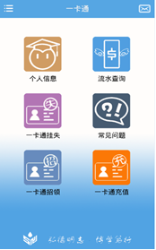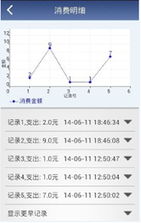
- (a) Card information (b) Data statistics

Campus Geographic Information System
Using Shandong Normal University as the place to develop the Campus Geographic Information System, it represents not only regular geospatial information, but also massive model datasets and distribution of surface features in the image. This can be superimposed on a map according to an actual situation, and establish linkages with specific geographical coordinates, as shown in Figure 2. The power of geospatial information lies in vivid virtual reality, which is based on detailed texture information and rendering technology ^{[9]}. It makes managing school spaces and attributes information more efficiently, intuitively and comprehensively, locates the campus facilities in accurate position, and provides a dynamic management platform for the school.

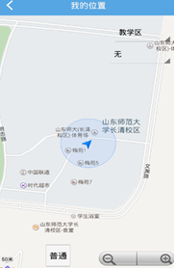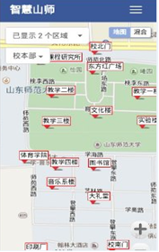
- (a) Location system (b) Campus map

Intelligent Library Management System
Currently, Shandong Normal University uses an advanced digital library management system, and locates the position of books to a shelf of the fixed layer through the RFID technology. In the library, they have self-help book borrowing and self-help book returning systems, the RFID electronic tags are used to store relevant information of shelves, books, and book carts. At the same time, in different customer application servers, one can query the relevant information of borrowed books, as shown in Figure 3.

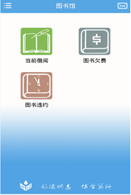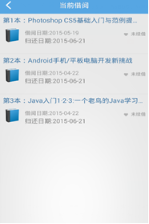
- (a) Books notice (b) Borrowed book information

Self-study Room Management System
This system is committed to implementing efficient management of seats in the self-study rooms. Students can query the usage and course information of each classroom through the mobile phone, tablet, computer and other equipment, while the curriculum information and academic curriculum are the same, as shown in Figure 4. It guides students to go into a suitable classroom in a short amount of time, significantly improving the usage rate of the teaching buildings, and creates a higher level of student satisfaction.

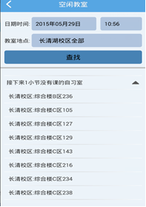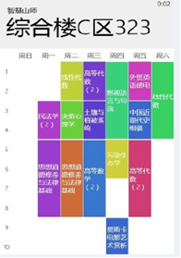
- (a) Classroom recommendation (b) Curriculum information

Bathroom Management System
Bathroom water control management based on the RFID technology, can detect the automatic management of water, while the RFID card reader is inside of the induction zone, the balance of a card is displayed in real-time, according to the used water flow accounting, the returned monitoring data is analyzed constantly, and then provides accurate information of the bathroom state, which can be accessed by students. This plays a convenient role in student life, as shown in Figure 5.

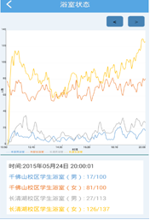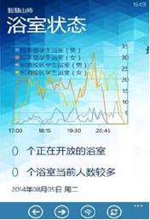
- (a) Bathroom monitoring data of different gender students in use (b) Smart recommendation of bathroom

Shuttle Bus Management System
This system can control the basic management of the unit inside. When a cardholder gets on a shuttle bus, use of a card will complete the identity recognition and car charge function. Identification and charging standards can be set by the user unit. Also, the user unit can achieve special requirements of the charging and billing functions through use of the card.
A vehicle-mounted machine is installed on each shuttle bus. While passengers get on the bus, they put the IC card on the vehicle induction area, if the card is valid, the vehicle issues a prompt allowing them to be board; otherwise, a warning prompt will ring out, notifying the driver that they need to verify the identity of the card holder. The car machine can automatically distinguish different types of IC cards (such as teacher cards, student cards, employee cards, temporary cards, etc.), and can deduct different costs according to the card business and time. As shown in Figure 6.

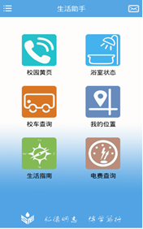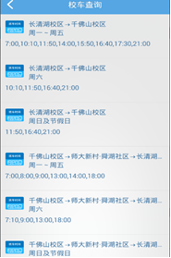
- Shuttle bus location and schedule

Flea Market Management System
The flea market system in smart campus can fully display each campus network users’ initiative. It can also, release and acquire information at a more convenient rate. It can compare similar products laterally to choose its own demand character, which is extremely consistent with college students when using campus cyber sources rationally. After the user signs on, they can browse the relevant products on a page freely. By clicking on the products, the system will retrieve and display product information from the database. If the user is satisfied with the goods, they can select the product and go on ordering operations, including choosing their payment method, delivery method, providing addresses for the purchaser and receiver of the product, contact numbers, order notes, and then the orders works, as shown in Figure 7. If a customer decided to make a purchase, they can release the provided information in a special purchase area. This area is where other users can contact them through private letter.
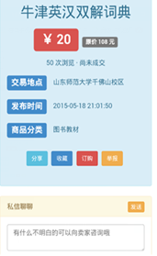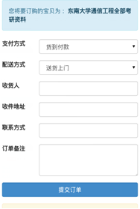
- (a) Commodity information (b) Submit order services.

News Management System
News management is mainly used to facilitate users in quickly checking the information on the digital campus platform. Three major application support platforms, including unified identity authentication platform, shared data centers, and unified information portal, are an important part of the construction of the smart campus project. Building these three platforms can audit identification of login platform and users’ identity in the system, and distribute a valid certificate to them, besides, displaying the school's public data on the unified information portal. Mobile clients and the server can perfect achieve docking with each other, according to a user's authorization. The corresponding function module system completes the information browsing, application downloads, topic participation, comments, and campus map operations.

Conclusion
In this paper, we point out an effective way of thinking in the construction of smart city, and carry on further research in the aspects of data analysis and of a decision making system:
- In the process of users using the application the system will produce a lot of data dealing with behavior and daily habits. The research of these data sets can allow us to learn a lot about the users' psychological fluctuations and orientation statues that a user values, which is conducive to the community holding the direction of public opinion, which helps to form guidelines and plans more rationally.
- The system server is set up in the cloud. It makes full use of cloud computing, and cloud storage technologies, enhancing the ability of data analysis. Using distributed storage systems, it helps to improve system security, and works at a fast speed to backup and recovery data.
- The results of this paper have found an increasingly wide utilization of enterprises and institutions portal system, as applied to the party and government organs. Smart cities will be places that foster creativity, where citizens are generators of ideas, services and solutions ^{[10]}, and city leaders can manage this growth to support positive economic and social application development.
In the near future, we intend to support cloud computing and networking technology, constructing a teaching-center made of a network of teaching management and resources sharing system; in the center of administrative affairs of school, constructing the office automation system, personnel information management system, mail management system, accumulated experience platform, and journal management system. We wish to focus campus life on the intelligent vegetation irrigation system and intelligent lighting control system, etc. Further research is then needed in order to continue in this direction.
Consequently, smart school management will open a new era of city management, which will significantly develop a city into a more scientific, intelligent and personalized space.

Acknowledgment
This work has been supported by National Natural Science Foundation of China(No.61572301) funded by National Natural Science Fund Committee, Shandong Normal University Information Technology Management Department and the Institute of Information Science and Technology.

References
- Ping Zong, Hongbo Zhu, Gang Huang, and Jianzhen Xu, “Research on the design method of Smart Campus,” Journal of Nanjing University, vol. 30, pp. 15-51, 2010(in Chinese).
- Yang Sun, “Talk of the smart campus,” Netfriends, vol. 2, pp. 5-6, 2014 (in Chinese).
- RFC 5849, The OAuth 1.0 Protocol, IETF.
- Wei Wang, Zhonghuan He, Diquan Huang, and Xi Zhang, “Research on service platform of internet of things for smart city,” The International Archives of the Photogrammetry, Remote Sensing and Spatial Information Sciences,vol.40, pp. 301-303, 2014.
- Ruiyu Huang, Smart campus construction program and Implementation, South China University of Technology publishing house, 2014, pp. 11(in Chinese).
- Margarita Angelidou, “Smart cities: A conjuncture of four forces,” Cities, vol.47, pp. 95-106, 2015.
- M. Mazhar Rathore, Awais Ahmad, Anand Paul, and Seungmin Rho, “Urban planning and building smart cities based on the Internet of Things using Big Data analytics,” Computer Networks, vol.101,pp. 63-80, 2016.
- G.Piro, I.Cianci, L.A. Grieco, G.Boggia, and P. Camarda, “Information centric services in Smart Cities,” The Journal of Systems and Software, vol.88, pp. 169-188, 2014.
- MAO Wei-qing, “Study on the construction and application of 3D geographic information services for the smart city,” ISPRS Annals of the Photogrammetry, Remote Sensing and Spatial Information Sciences, vol.2, pp. 41-44, 2014.
- Haque.U.Surely, “there’s a smarter approach to smart cities?” April 2012, Available: http://blog.pachube.com/2012/04/surely-theres-smarter-approach-to-smart.html.

